**Project Design Phase-II**

**Technology Stack (Architecture & Stack)**

|  |  |
| --- | --- |
| Date | 20 November 2023 |
| Team ID | Team-592061 |
| Project Name | River Water Quality Forecasting |
| Maximum Marks | 4 Marks |

**Architecture Diagram Using The Given Tables:**

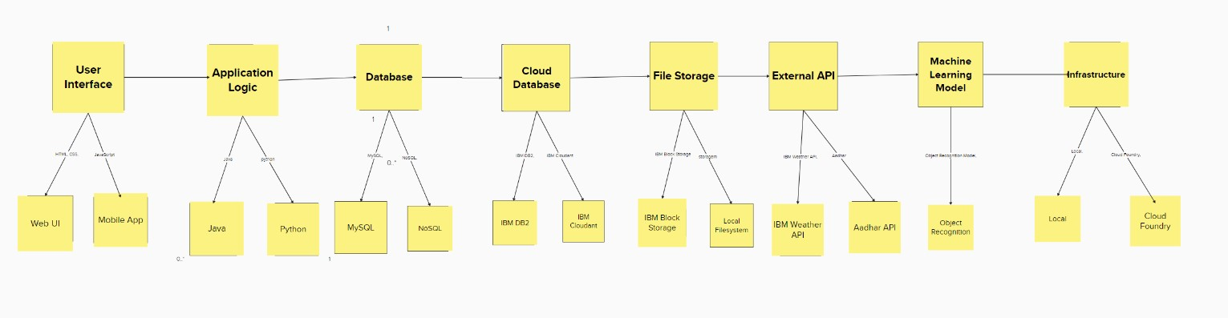

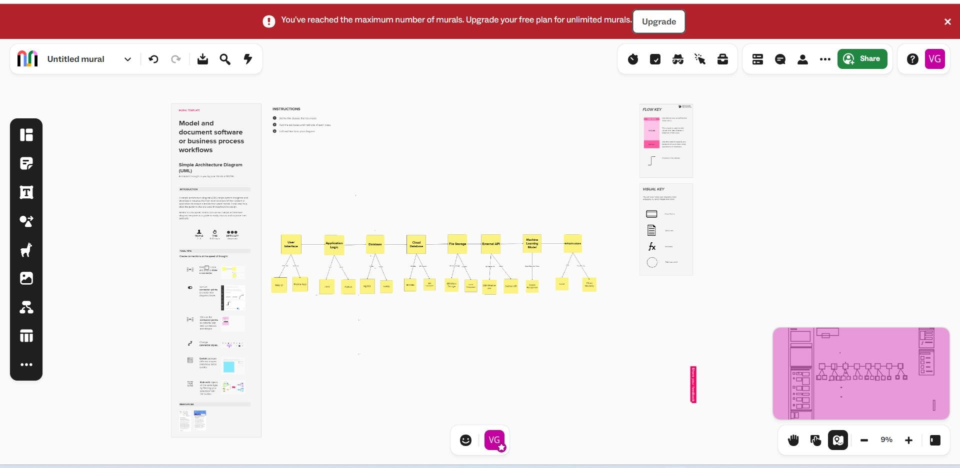

**Table-1 : Components & Technologies:**

|  |  |  |  |
| --- | --- | --- | --- |
| **S.No** | **Component** | **Description** | **Technology** |
| 1. | User Interface /Front End | How user interacts with application e.g. Web UI, Mobile App, Chatbot etc. | HTML, CSS, JavaScript |
| 2. | Backend | Logic for a process in the application | Flask |
| 3. | Application Logic-1 | Logic for a process in the application | Flask |
| 4. | Machine Learning Model | Predicts water potability based on input parameters | Scikit-Learn,SVM |
| 5. | Data Preprocessing | Prepares input data for the machine learning model | Pandas,Numpy |
| 6. | External API-1 | Purpose of External API used in the application | REST, JSON |
| 7. | Deployment | Deploying the web application on a cloud platform | Heroku,Docker |
| 8. | Model Persistence | Saves and loads the trained machine model | Pickle,joblib |
| 9. | Infrastructure (Server / Cloud) | Application Deployment on Local System / Cloud  Local Server Configuration:  Cloud Server Configuration : | Heroku, Docker. |

**Table-2: Application Characteristics:**

|  |  |  |  |
| --- | --- | --- | --- |
| **S.No** | **Characteristics** | **Description** | **Technology** |
| **1.** | Open-Source Frameworks | List the open-source frameworks used | Flask, Scikit-Learn |
| **2.** | Nature of Application | Water quality prediction web Application | ____ |
| **3.** | User Interface(UI) | Simple input form for users to input water quality parameters .Responsive design for various screes sizes | HTML,CSS |
| **4.** | Availability | Justify the availability of application (e.g. use of load balancers, distributed servers etc.) | Load Balances, Redundancy, High-Availability configuration |
| **5.** | Performance | Design consideration for the performance of the application (number of requests per sec, use of Cache, use of CDN’s) etc. | Performance Monitoring Tools, Caching Mechanisms |

**Table-3 : Technology Stack:**

|  |  |
| --- | --- |
| Component | Technology/Tool |
| Data Analysis | Pandas, Numpy |
| Visualisation | Matplotlib, Seaborn |
| Machine Learning | Scikit-Learn |
| Web Framework | Flask |
| Frontend | HTML, CSS |
| Version control | Git, GitHub |
| Deployment | Heroku, Docker |